Unit 5 Lesson 1-Han Empire
1  blast furnace  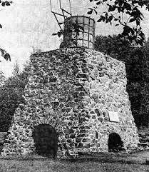  a structure used for smelting iron where combustion is intensified by blowing air through a hot mixture of ore, coke and flux  Example: The iron ore was melted in the blast furnace. | 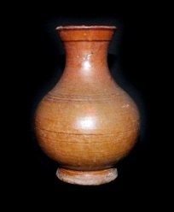  2  ceramics  an object such as earthenware, porcelain or tile made of from fired clay  Example: The development of ceramics allowed people to store food for longer periods of time in strong containers.
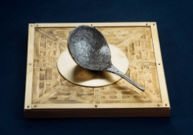  3  compass  an instrument containing a magnetized pointer that shows the direction of magnetic north and bearings from it  Example: The explorers found their way back to the coast using their compass. | 4  meritocracy  government or the holding of power by people selected on the basis of their ability  Example: Those people with the highest test scores were able to gain higher positions in the civil service.
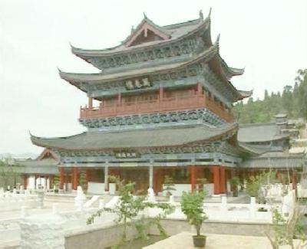  5  imperial  of, like, or pertaining to an empire  Example: The imperial palace was a place of beauty and power. | 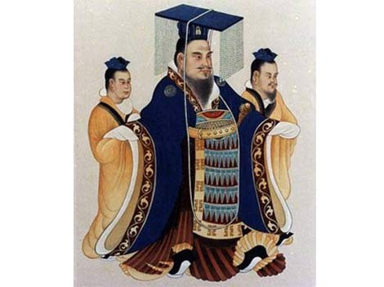  6  dynasty  a line of hereditary rulers of a country or empire  Example: China was ruled by several different dynasties that passed power from person to person within the same family.
7  militarization  the process by which a society equips or trains for war  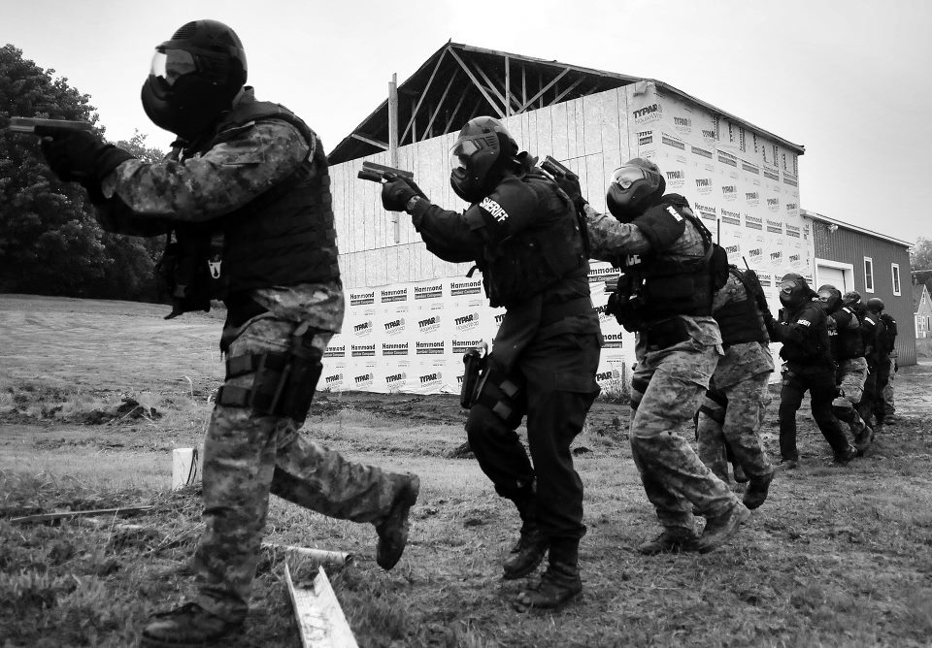  Example: Rulers wanting to expand their control usually promote the militarization of society. | 8  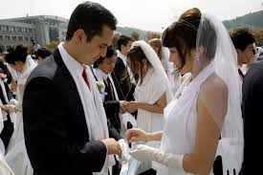  unification  to consolidate or bring together  Example: The unification of thirteen colonies formed the United States.

Unit 5 Lesson 2-Roman Empire
9  innovation  the act of translating an idea or invention into something new  Example: The development of concrete was an important innovation in architecture and building. | 10  aqueduct  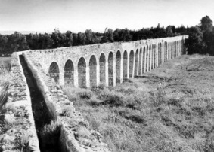  a pipe or channel designed to carry water from a faraway source to someplace else, usually using gravity to help move the water along  Example: The Romans used aqueducts to bring water from the mountains to the low-lying city of Rome.
11  viaduct  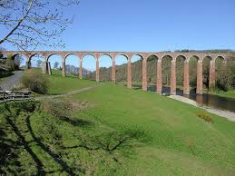  a bridge with several different parts, usually arches or spans, built to cross a valley, gorge, or river  Example: They built a viaduct to make it easier to get across the deep gorge. | 12  civil engineering  the use of science, math, and other forms of specialized knowledge to design, build, and maintain buildings, other structures, machines, etc.  Example: Roman engineering made many contributions to the modern planning of roads and bridges.
13  bust  a sculpture depicting a person's head and shoulders  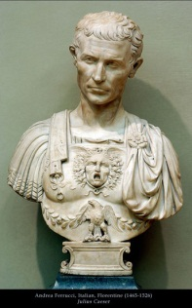  Example: There are many busts of famous Roman emperors. | 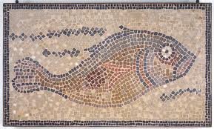  14  mosaic  the art of creating images by piecing together small pieces of colored glass, stone, or other materials  Example: The Romans created many beautiful mosaics using small pieces of colored glass.
15  public health -the science of preventing disease and promoting health in the overall public through organized group action and policies.  Example: Providing clean drinking water was an important part of the Roman’s contributions to public health. | 16  architecture  The art or practice of designing and building structures  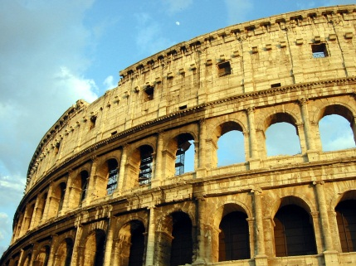  Example: Roman architecture reflected a heroic style seen best in the Coliseum and other buildings.
17  adaptation  the process or state of changing to fit a new environment or different conditions  Example: The United States capitol building is an adaptation of Greco-Roman architectural forms. | 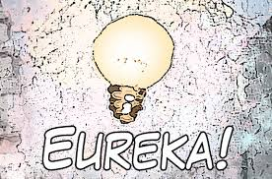  18  invention  creating an object, process or technique that did not exist before  Example: Inventions of the 20th Century include the television, computer, and cell phone.

Unit 5 Lesson 3-Gupta Empire
19  middleman  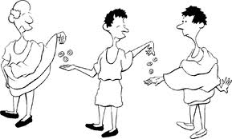  an intermediary or agent between a producer and a consumer of goods or services  Example: The middleman in the exchange had contact with both producer and ultimate consumer. | 20  crossroads  a place where two or more roads meet  Example: They parted at the crossroads, each heading in a different direction.
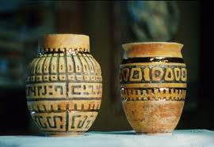  21  artifact  any object made or used by mankind  Example: The archaeologist found a falcon sculpture at the site. | 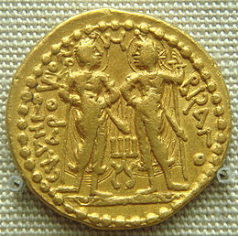  22  coin  a usually flat piece of metal issued by governmental authority as money  Example: They used coins to facilitate trade.
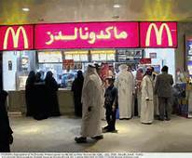  23  cultural diffusion  the spreading of ideas or products from one culture to another.  Example: Improvements in technology has increased cultural diffusion across the planet. | 24  trade  the act or process of exchanging goods or services one has for the goods or services one wants  Example: We can obtain the resources we need through trade.

Unit 5 Lesson 4-Mayan Empire
25  codex  (codices- plural)  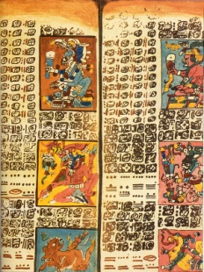  a book made up of a number of sheets of paper, vellum, papyrus, or similar material, with hand-written content  Example: The Mayan created many codices that were later destroyed. | 26  Yucatan  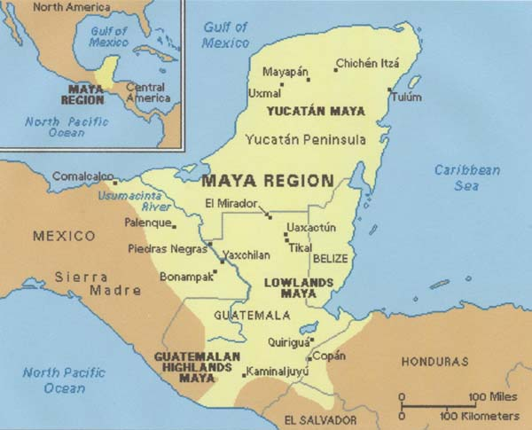  a peninsula that sticks into the Gulf of Mexico and the Caribbean, located in the southeastern part of Mexico and northern Guatemala.  Example: The Yucatan peninsula was where many Mayan cities were located.
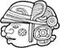  27 glyph  a symbolic figure or character used in a writing system  Example: The Mayans used a wide range of glyphs in their writing system. | 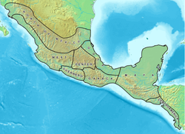  28  Mesoamerica  the cultural region from central Mexico down into Central America  Example: The Mayans lived in Mesoamerica.

Unit 5 Lesson 5-Golden Age of Gupta
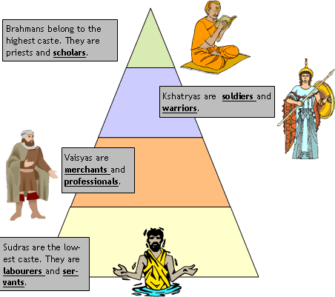  29  caste system  a social hierarchy that divides up labor and power across different groups that are determined by birth with people in lower castes having the most difficult or unwanted jobs and the least power  Example: The Untouchable caste in India did the dirtiest work and generally got paid less than others. | - 30  - monk  - a member of a religious community of men typically living under vows of poverty, purity, and obedience  Example: Chinese monks traveled to India to learn about Buddhism where it began.
31  patriarchy  a social system in which men are the head of families and have authority over women and children  Example: Women today still struggle to have equal rights and many speak out against patriarchy. | 32  prosperity (prosperous)  being prosperous, having good fortune, wealth, and well-being  Example: It was a time of prosperity because most people living in the society worked and enjoyed financial well-being.
33  tolerant  willing to accept or respect ideas or people that you don’t agree with  Example: Some Indian emperors were tolerant of different religious groups. | 34  alliance  a relationship in which people agree to work together  Example: The countries formed an alliance in trade.

Unit 5 Lesson 6-Why Empires Collapse
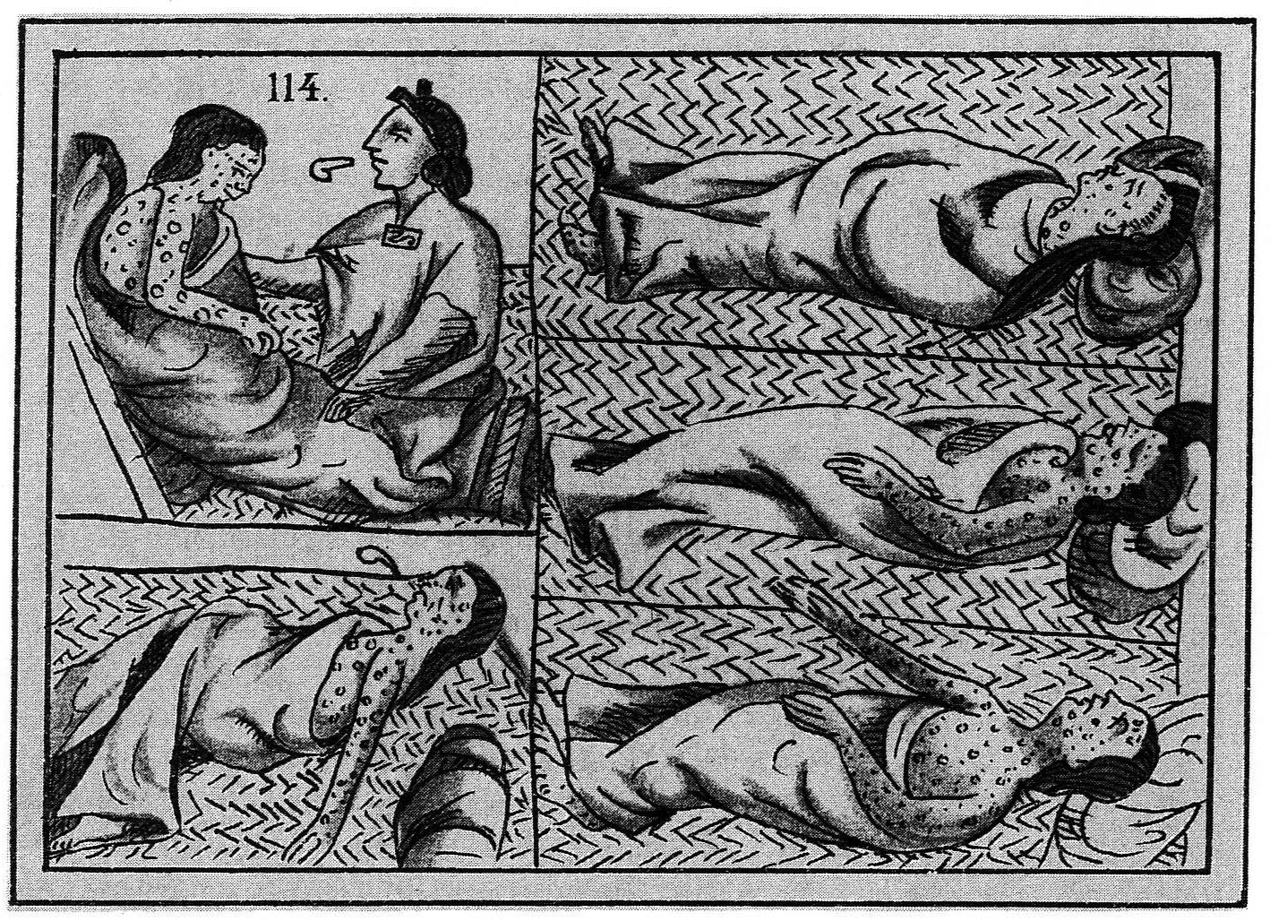  35  epidemic  the spread of an infectious disease through many people in one area during a specific time period  Example: An epidemic of smallpox killed many Native Americans when Europeans began to colonize the Americas. | 36  corruption  dishonest action by those in power  Example: The official was accused of corruption after stealing tax money meant for schools.
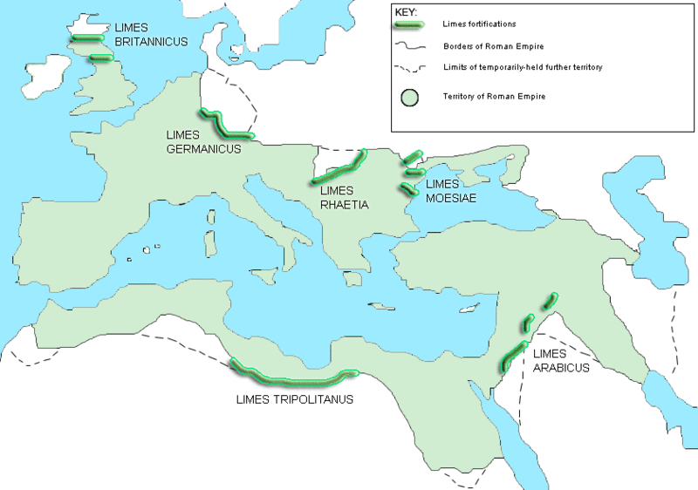  37  border  the defined geographic boundary of a state, nation, empire, etc.  Example: The borders of the Roman Empire stretched across Europe, into Asia, and down into North Africa. | 38  rebellion  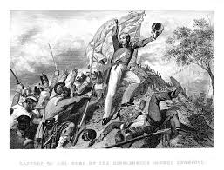  violent or open resistance (fighting against) an existing government  Example: The slave Spartacus led a rebellion against the Roman Empire.
39  tax  when a government requires people and/or organizations to make contributions of money or goods to fund the government  Example: The farmers had to give the empire some of their grain as a tax. | 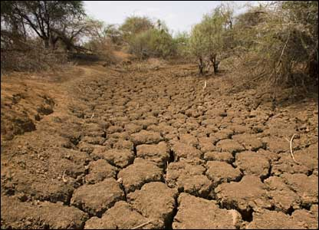  40  drought  an extended period of dry weather  Example: During the drought, there was no rain for months and many of the farmer’s crops died.

Unit 5 Lesson 7-Turning Point and other stories
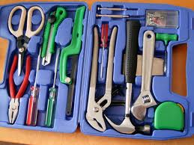  40  progress  the process of improving or developing something over a period of time  Example: You can see the progress that gaming companies have made by comparing computer games today to those available ten years ago. | 41  intensification  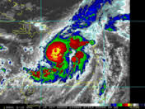  to heighten or increase in strengthen or magnitude; an action that makes something stronger or more extreme  Example: Some scientists believe that the intensification of droughts and storms in recent years is due to climate change.
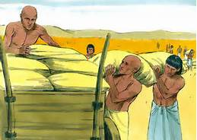  42  surplus  the amount that remains when a use or need is satisfied  Example: They stored the surplus grain for use at a later time. | 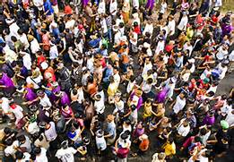  43  population  the total number of people who live in a place, area, region, or country  Example: The population of the world continues to increase.
44  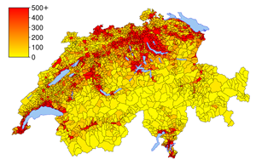  population density  a measure of how many people live in a per unit area (e.g., per square mile)  Example: The population density of New York is greater than Wyoming. | 45  increase  to make or become larger or greater in number, quality or degree  Example: The increase in the number of slaves under Roman rule was a consequence of territorial expansion.
46  decrease  to make or become smaller or fewer in terms of number, quality, or degree  Example: When disease spread through a region, the population decreased. | 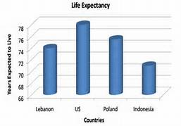  47  life expectancy  the number of years that one will probably live as determined by statistics; an average life span of an individual  Example: Life expectancy for women is higher than for men.
48  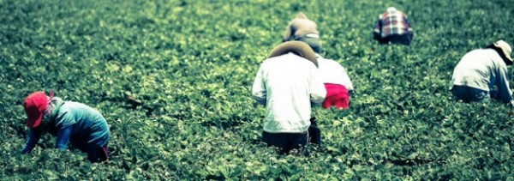  toiled  hard and continuous work  Example: Slaves and laborers toiled in the hot sun for hours. | 49  alphabetic writing systems  a way of representing language visually through symbols based on the principle that the letters represent the sounds of speech  Example: The Phoenicians, Greeks and Romans used alphabetic writing systems.
50
turning point
an important historical event that has long lasting effects on human life
Example: The invention of the printing press was a major turning point because it brought books into common homes for the first time.

